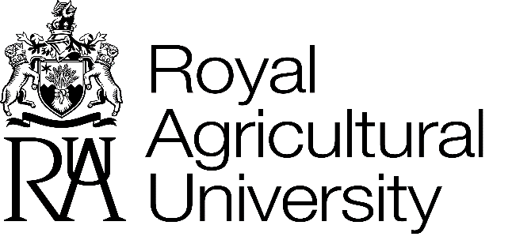

Work Placement Providers Privacy Notice

The Royal Agricultural University (RAU) is a data controller and is committed to protecting your personal data and working in accordance with all relevant data protection legislation. This privacy notice explains how the University processes and uses the personal data we collect about RAU work placement providers. Your data is used for course delivery and to contact you about opportunities for work placements for RAU students.
The University will process your data in compliance with the General Data Protection Regulation (GDPR) which came into effect on 25th May 2018.

WHAT DATA DO WE HOLD?
The University may hold data relating to you from a number of sources. The majority of data we hold on networking group members and work placement providers is predominantly provided by you, but may be augmented with publically available data from other sources (see below).

OUR RECORDS MAY INCLUDE
Personal Identifiers and Biographical Information – for example your name and your age.
Contact Details – for example your address, email address and telephone number (we update these whenever you tell us they have changed)
Business Contact Details – for example the name of your employer, your role and the address of your office.
Education Details – for example what you studied and when you graduated if you were an RAU graduate (or if you have provided us with this information).
Personal Details – for example disability and dietary preferences for event management purposes.
Your Preferences – to help us engage you in the ways most relevant to you, for example, how you prefer to receive news and information from us.
We may also augment data you provide with data which is publicly available, for example we may record:
- Your career details and other achievements
- Your interests

Any other personal data required to carry out the legitimate business of the University.

We are required to ensure that data we hold about you is as accurate as possible, therefore we may update your details based on reliable publicly available sources, as well as updates which you provide to us. For example we may update your address, telephone number or business details.
We will retain your data for as long as you remain a member of the networking group to which you signed up, or for as long as you are willing to continue to provide mentoring and work placements to RAU students (whichever is applicable).

CCTV
For our use of CCTV on campus, please see the CCTV policy.

IP ADDRESSES, COOKIES AND YOUR DEVICES
We may collect information about the device/s you are using to access our online services, the operating system and browser type used and your IP address. This is intended to provide aggregated data about users' behaviours and does not identify any individual. It is used to inform improvements to the website, for system administration, and to report aggregate information to third party sub-contractors we may be working with in areas such as advertising, search information providers, analytics providers or in technical delivery services.

We may also obtain information about your general internet usage relating to our websites by using a pixel or a cookie file, which is stored on the hard drive of your computer. Again this is used to provide aggregated data on how users access and navigate our websites, and to assess their usefulness. Personal information about you is not collected during the tracking process.

HOW DO WE USE YOUR DATA?
The University primarily uses your data to communicate about students looking for work placements and opportunities to meet and interact with students. These can include:
- Sending you details about current students
- Inviting you to events
- Informing you of benefits available to RAU supporters
- Inviting you to be a speaker, tutor or presenter on one of our courses.
Communications may be sent to you by post, telephone, email, or other electronic means (for example through social media) depending on the communication preferences you have shared with us.

HOW WILL WE SHARE YOUR DATA?
Data may be shared with the Alumni team for the purpose of alumni activities, fundraising programmes or the promotion of benefits and services. These activities may include an element of direct marketing, to which you have the right to object.
Data may be shared with the Commercial team, including dietary and mobility needs, for the purposes of providing accommodation or for catering, should you visit the RAU site.
The data is also available to other departments within the University, through nominated members of staff.
Data will be shared with students in order to enable them apply for work placements. This will be done on an individual basis, and students will only receive the details of relevant contacts. Students will undertake to ONLY use this data for the purpose of arranging a work placement.
Data is only shared in support of the University and is never shared with anyone to enable other charities to contact individuals.
The University does NOT sell data to third parties or allow third parties to sell on data where data is shared with them.

HOW DO WE PROTECT YOUR DATA?
Your data is held securely on the University’s file storage system. The system is accessible to a limited number of University staff. All staff who access the data have completed the University’s data protection training.
The University ensures that appropriate data sharing agreements are in place prior to sharing your personal data with any partners.
YOUR RIGHTS AND PREFERENCES
You have the right to:
- Ask us to see, correct or delete the data we hold about you.
- Object to specific data uses, as described above.
- Object to receiving communications and direct marketing.
- Ask for the transfer of your data electronically to a third party.
The University may contact you by post unless you request otherwise, and by telephone, text, email or other electronic means as you have previously consented.
If you no longer want to receive communications by post, telephone, email or other electronic means, please contact the University on 01285 652531 or dataprotection@rau.ac.uk
When contacting us please provide your name, year and subject of course. Please also specify if you wish to unsubscribe from all communications or from specific communication types or methods.
If you ask us to delete your data and you are an alumnus, we will maintain a skeleton record comprising your name, subject of study, year of course, and date of birth, to ensure that we do not inadvertently contact you in future.
We will not obtain personally identifying information about you on our website, unless you choose to provide such information to us.

LEGAL BASIS FOR PROCESSING
The legal basis for processing your personal data for the purposes as described above is that it is necessary for the pursuit of our legitimate interests as an educational institution to for delivery of current courses, to provide educational resource and experiences for students and to .
Where you have provided your data to us and indicated that you are happy for us to use it to contact you, we may also process some data on the basis of consent (for example email addresses).

OTHER INFORMATION
This privacy notice will be kept under review. Any changes will be updated on our website and communicated to you as appropriate. This privacy notice was last updated in March 2019.
The University’s Data Protection Officer is responsible for monitoring compliance with relevant legislation in relation to personal data and can be contacted at dataprotection@rau.ac.uk
You can also contact the DPO if you have any queries or concerns about the University’s processing of your personal data. You have the right to lodge a complaint with the Information Commissioner’s Office at www.ico.org.uk/concerns

Further information:
If you have any questions regarding this privacy notice please do not hesitate to contact us at dataprotection@rau.ac.uk

