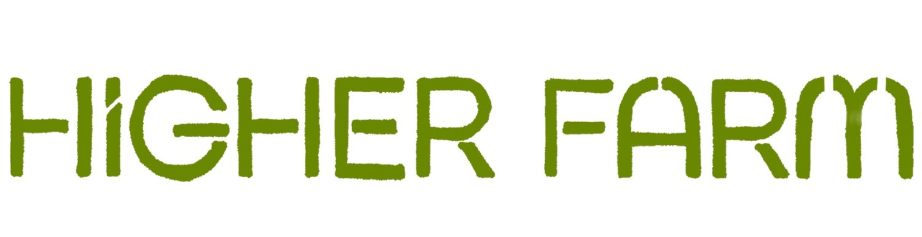

Higher Farm is hiring a Produce & Products Sales & Distribution Manager to build and scale our food and farming start-up!!

If you are interested in applying, please email [giacomo@higher-farm.co.uk](mailto:giacomo@higher-farm.co.uk) and [matteo@higher-farm.co.uk](mailto:matteo@higher-farm.co.uk) with coverletter and CV.

Come join the food revolution!!

Please see details below 🌳

Full job description:

We are a natural food and farming business, situated on our 50 acre farm in Somerset, tackling the deepest problems in our food system. We are a young startup, and looking for someone to manage and lead the growth of our fresh produce and food products business.

Job Summary:

We are looking to build a trailblazing food brand that champions natural and local principles. You will be managing the sales and distribution of two key business lines: Fresh Produce and Food Products. Fresh produce entails natural fruit and veg grown on our farm, which we are looking to scale to a nationwide veg box business, and sell into local farmers' markets, restaurants and shops. For Food Products, we are developing scalable natural food products, backed by our young and progressive brand, that can out-compete ultra-processed competitors.

Key responsibilities include:

Business development:

- Increasing revenue both D2C and D2B

- Build and maintain strong relationships with accounts including, wholesalers, retailers, restaurants, households and other food services businesses

- Lead the launch of new retail products

- Work closely with our Marketing Manager to deliver sales targets

- Grow veg box business

- Scale our food products to nationwide distribution

Distribution management :

- Design and manage our new distribution warehouse

- Build operations systems to fulfill orders efficiently

- Work with farm managers to distribute fresh produce supply

- Establish manufacturing system with outsourced parties to scale the production of retail products nationwide

Crucially, you will be joining a young company and building this department from the ground up.

We are looking for:

- Builder and creator mindset

- High-energy and able to deal with fast pace work environment

- Problem solver and enterprising spirit

- Team player and collaborative mindset

- Efficient communicator

- Mission focused and highly passionate

Job Types: Full-time, Permanent

**Pay: £40,000.00-£60,000.00 per year**

Experience: 5+ years management of sales & distribution for food products company

Work Location: In person (Higher Farm, Sutton, BA4 6QF